# Lab: Regular Expressions

You can check your solutions in [Judge.](https://judge.softuni.org/Contests/1672/Regular-Expressions-Lab)

## Match Full Name

Write a Java Program to **match full names** from a list of names and **print** them on the console.

### Writing the Regular Expression

First, write a regular expression to match a valid full name, according to these conditions:

* A valid full name has the following characteristics:
  + It consists of **two words**.
  + Each word **starts** with a **capital letter**.
  + After the first letter, it **only contains lowercase letters afterward**.
  + **Each** of the **two words** should be **at least two letters long**.
  + The **two words** are **separated** by a **single space**.

To help you out, we've outlined several steps:

1. Use an online regex tester like <https://regex101.com/>
2. Check out how to use **character sets** (denoted with square brackets - '[]')
3. Specify that you want **two words** with a space between them (the **space character '** **'**, and **not** any whitespace symbol)
4. For each word, specify that it should begin with an uppercase letter using a **character set**. The desired characters are in a range – **from** '**A**' **to** '**Z**'.
5. For each word, specify that what follows the first letter are only **lowercase letters**, one or more – use another character set and the correct **quantifier**.
6. To prevent letters' capture across new lines, put "\b" at the beginning and the end of your regex. This will ensure that what precedes and what follows the match is a word boundary (like a new line).

To check your RegEx, use these values for reference (paste all of them in the **Test String** field):

|  |  |
| --- | --- |
| **Match ALL of these** | **Match NONE of these** |
| Ivan Ivanov | Ivan Ivanov, Ivan ivanov, ivan Ivanov, IVan Ivanov, Georgi Georgiev, Ivan Ivanov |
| Peter Georgiev | peter georgiev, peter GeOrgiev, Peter GeORgiev, PEter GEorgiev, Peter Georgiev, Anna Petrova |

By the end, the matches should look something like this:





After you've constructed your regular expression, it's time to write the solution in Java.

### Implementing the Solution in Java

Create a new Java project and copy your **regular expression** into a String variable:

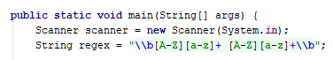

Now, it's time to **read the input** and create two **classes** to help us work with **regular expressions**:

* **Pattern Class** − A Pattern object is a compiled representation of a regular expression.
* **Matcher Class** − A Matcher object is the engine that interprets the pattern and performs match operations against an input string.

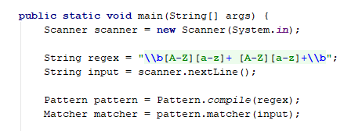

Now, it's time to **extract all the matches** from our input and print them. We use the matcher method **find(),** which **attempts to find the next subsequence of the input sequence that matches the pattern.** To get our matches, we need to use method **group().**

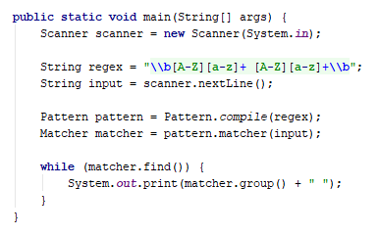

### Examples

|  |
| --- |
| **Input** |
| Ivan Ivanov, Ivan ivanov, ivan Ivanov, IVan Ivanov, Georgi Georgiev, Ivan Ivanov |
| **Output** |
| Ivan Ivanov Georgi Georgiev |
| **Input** |
| peter georgiev, peter Georgiev, Peter GeoRgiev, PEter GEorgiev, Peter Georgiev, Anna Petrova |
| **Output** |
| Peter Georgiev Anna Petrova |

## Match Phone Number

Write a regular expression to match a **valid phone number** from **Sofia**. After you find all **valid phones**, **print** them on the console, separated by a **comma and a space** ", ".

### Compose the Regular Expression

A valid number has the following characteristics:

* It starts with "**+359**".
* Then, it is followed by the area code (always **2**).
* After that, it's followed by the **number** itself:
  + The number consists of **7 digits** (separated into **two** **groups** of **3** and **4** **digits,** respectively).
* The different **parts** are **separated** by **either a space or a hyphen** ('**-**').

You can use the following RegEx properties to **help** with the matching:

* Use **quantifiers** to match a **specific number** of **digits.**
* Use a **capturing group** to ensure the delimiter is **only one of the allowed characters** **(space or hyphen)** and **not** a **combination** of both (e.g., +359 2-111 111 has **mixed delimiters**, it is **invalid**). Use a **group back reference** to achieve this.
* Add a **word boundary** at the **end** of the match to avoid **partial matches** (the last example is on the right-hand side).
* Ensure that before the **'+'** sign, there is either a **space** or the **beginning of the string**.

You can use the following table of values to test your RegEx against:

|  |  |
| --- | --- |
| **Match ALL of these** | **Match NONE of these** |
| +359 2 222 2222  +359-2-222-2222 | 359-2-222-2222, +359/2/222/2222, +359-2 222 2222  +359 2-222-2222, +359-2-222-222, +359-2-222-22222 |

### Implement the Solution in Java

Now it's time to write the solution, so let's start writing!

First, just like in the previous problem, put your RegEx in a variable:

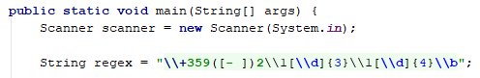

Again we need a **Pattern** and **Matcher.**

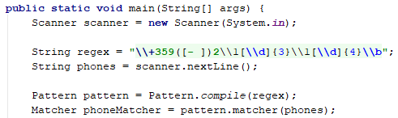

We can also save our matches in a List if we need.

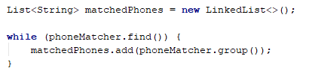

After that, just print the valid phone number list using a string.Join():



### Examples

|  |
| --- |
| **Input** |
| +359 2 222 2222,359-2-222-2222, +359/2/222/2222, +359-2 222 2222 +359 2-222-2222, +359-2-222-222, +359-2-222-22222 +359-2-222-2222 |
| **Output** |
| +359 2 222 2222, +359-2-222-2222 |
| **Input** |
| +359 2 222 2222,359-2-222-2222, +359/2/222/2222, +359-2 222 2222 +359 2-222-2222, +359-2-222-222, +359-2-222-22222 +359-2-222-2222 |
| **Output** |
| +359 2 222 2222, +359-2-222-2222 |

## Match Dates

Write a program that matches a date in the format "dd{separator}MMM{separator}yyyy". Use **named** **capturing groups** in your regular expression.

### Compose the Regular Expression

Every valid date has the following characteristics:

* Always starts with **two digits**, followed by a **separator.**
* After that, it has **one uppercase** and **two lowercase** letters (e.g., Jan, Mar).
* After that, it has a **separator** and **exactly 4 digits** (for the year).
* The separator could be either of three things: a period ("."), a hyphen ("-") or a forward-slash ("/").
* The separator needs to be **the same** for the whole date (e.g., 13.03.2016 is valid, 13.03/2016 is **NOT**). Use a **group back reference** to check for this.

You can follow the table below to help with composing your RegEx:

|  |  |
| --- | --- |
| **Match ALL of these** | **Match NONE of these** |
| 13/Jul/1928, 10-Nov-1934, 25.Dec.1937 | 01/Jan-1951, 23/sept/1973, 1/Feb/2016 |

Use **named capturing groups** for the **day**, **month,** and **year**.

Since this problem requires more complex RegEx, which includes **named capturing groups**, we'll take a look at how to construct it:

* First off, we don't want anything at the **start** of our date, so we're going to use a **word boundary** "\b":  
  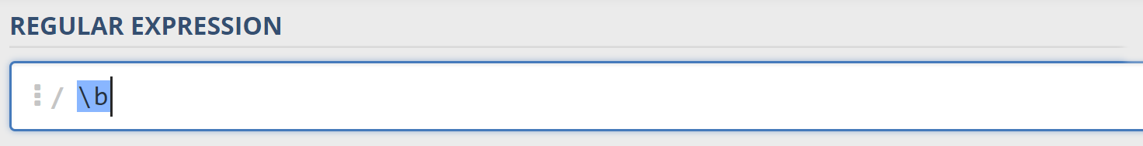
* Next, we're going to match the **day** by telling our RegEx to match **exactly two digits**,and since we want to **extract** the day from the match later, we're going to put it in a **capturing group**:  
  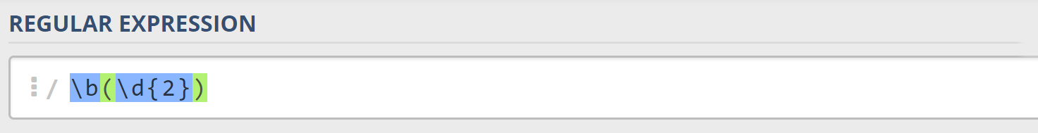  
  We're also going to give our group a **name** since it's easier to navigate by **group name** than by **group index**:  
  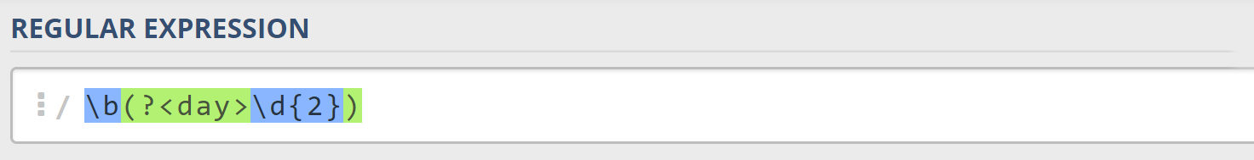
* Next comes the separator – either a **hyphen**, **period,** or **forward slash**. We can use a **character class** for this:  
  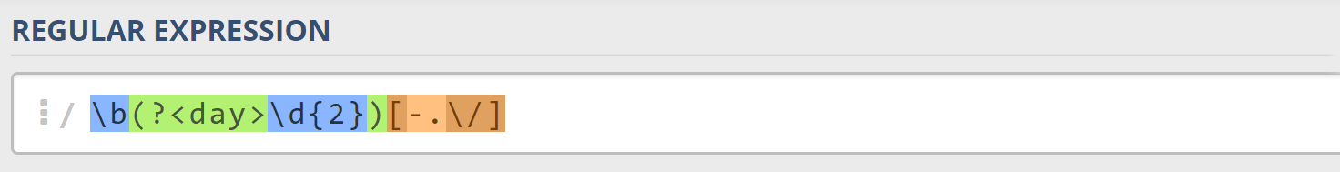  
  Since we want to use the separator we matched here to match the **same separator** further into the date, we're going to put it in a **capturing group**:  
  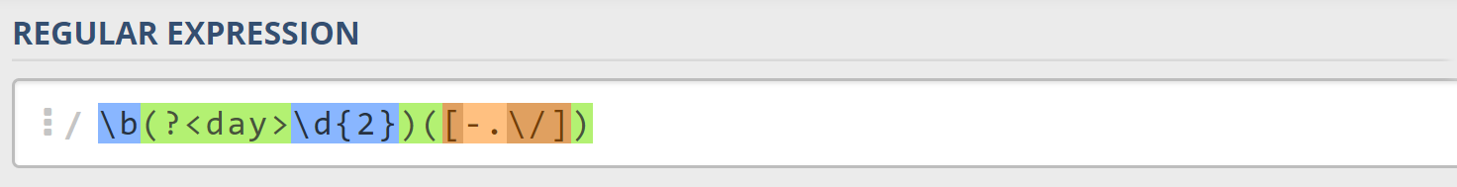
* Next comes the **month**, which consists of a **capital Latin letter** and **exactly two lowercase Latin letters**: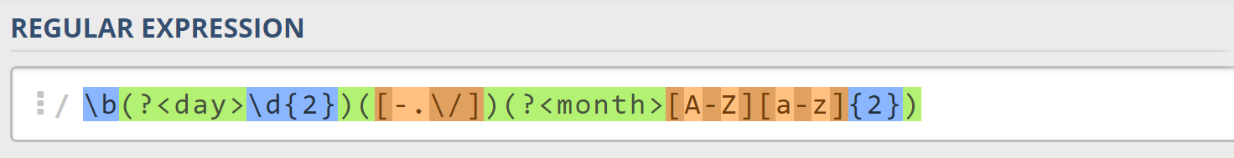
* Next, we're going to match the **same separator** **we matched earlier**. We can use a **back reference** for that:  
  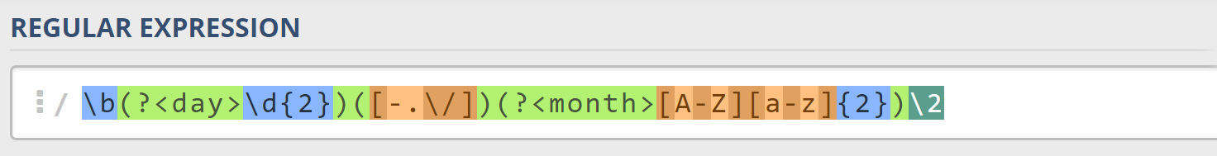
* Next up, we're going to match the year, which consists of **exactly 4 digits**:  
  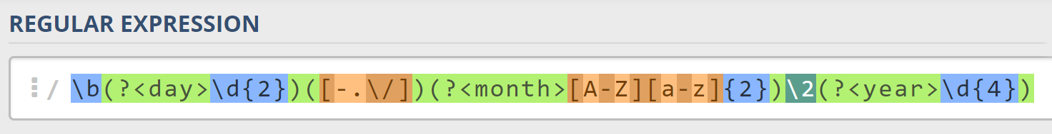
* Finally, since we don't want to match the date if there's anything else **glued to it**, we're going to use another **word boundary** for the end:  
  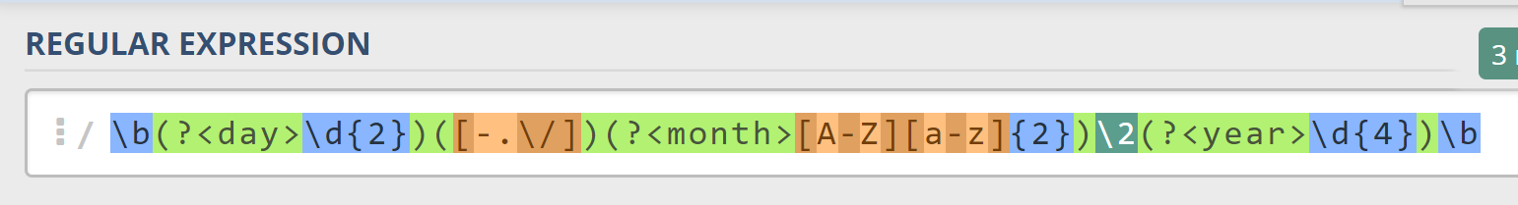

Now it's time to find all the **valid dates** in the input and **print each date** in the following format: "Day: {day}, Month: {month}, Year: {year}", each on a **new line**.

### Implement the Solution in Java

First off, we're going to put our RegEx in a variable.

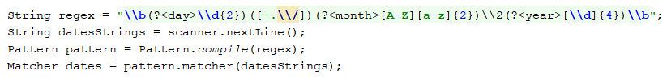

Next, we're going to **iterate** over every single Match and **extract** the **day**, **month,** and **year** from the **groups.**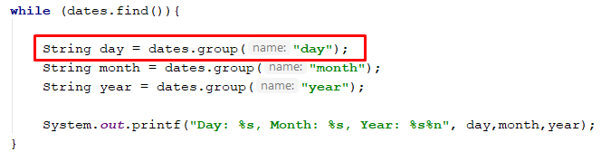

### Examples

|  |
| --- |
| **Input** |
| 13/Jul/1928, 10-Nov-1934, , 01/Jan-1951,f 25.Dec.1937 23/09/1973, 1/Feb/2016 |
| **Output** |
| Day: 13, Month: Jul, Year: 1928  Day: 10, Month: Nov, Year: 1934  Day: 25, Month: Dec, Year: 1937 |
| **Input** |
| 01/Jan-1951 29/Feb/2024 1/Jan-1951 27-Feb-2007 1/Jan-1951 1/Mar/2016 23/october/197 |
| **Output** |
| Day: 29, Month: Feb, Year: 2024  Day: 27, Month: Feb, Year: 2007 |